DC Circuits PHYS 501 Homework 2

NAME:__________________________(partner if any: ________________________)
In-class Laboratory. Worth 12 points.

A "circuit" is a circular (completed) path from the red or "+" side of a voltage source through various "circuit elements" (resistors, diodes, capacitors, motors, light bulbs, etc.) back to the black or "–" side of the voltage source. One point of the circuit can be "grounded", which is connected to the Earth by a copper post or deep water pipe.
These symbols show some of the common circuit elements. A diode only lets current flow one way (the direction of the arrow). A resistor slows down the flow of current.

A variable resistor or variable inductor or capacitor will have an arrow running diagonally through it.
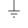
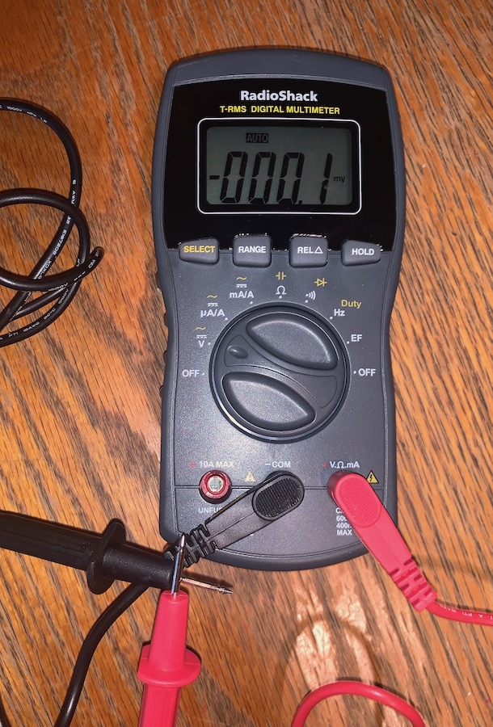
This is ground:

We will use a Digital MULTIMETER, which can measure EMF (volts), resistance (ohms), and current (amps). I strongly recommend owning one of these – you can get it at the local hardware or tool store. Change the range on the meter BEFORE you attach it to the circuit, and be sure to turn it OFF when you are done.
To measure VOLTS, you attach patch cords from the COM and the + sockets ACROSS (in parallel with) the circuit element (usually the power supply, but could also be a resistor).
To measure AMPS, you put the meter IN SERIES with the rest of the circuit… the current flows through the meter.
To measure OHMS, you again put the meter in parallel to the resistor you wish to measure, but be sure there is no current flowing in your circuit to be tested. This uses power so be sure to turn this function off when done. (note this meter has a slightly different layout than the one in class).

We will make circuits by using patch cords, with "banana plugs" on the end. We have a premade "circuit box" with various elements, each with TWO sockets, one for the current to enter the element, and one for it to exit.

1. Plug the long red patch cord into the red socket of the power supply and the long black into the black. Turn the power supply on. Then attach the leads to the holes near the light bulb (in the bottom left corner). Can you make it light?? ______
Note how bright it is when the voltage source is all the way up (dial turned to the right). Switch the leads into the two sockets for the light bulb. Does it matter which way the current flows?

_________________________

2. Now add the ammeter into the circuit. Turn the multimeter to "mA" (milliamps). (the source is limited so that it doesn't go more than about 95 mA). Take the red patch cord out of the light socket and put it into the RIGHT socket of the ammeter, and put another red patch cord from the "com" (MIDDLE) socket of the ammeter to the red socket of the light. Now the ammeter is "in" the circuit. (The current flows through the ammeter on its way to the light.)
What does the current read? _______mA (if it goes offscale, turn the source down until it reads an even number of milliamps.)
IF IT READS ZERO, the fuse is blown. Ask for another multimeter, but never put the multimeter on "amps" if you don't have a resistor (or light) in the circuit.
Turn the voltage down until the light just barely lights…. What current do you read?

______mA

3. Take the ammeter out of the circuit by removing its cables and plugging the two red cables together so the current goes directly to the light and back to the power supply. Now measure the voltage output of the source with the multimeter. Turn the voltmeter to V (=) which means DC volts. Put a red cable from the red socket of the voltage source to the LEFT socket of the multimeter and a black cable from the black socket of the source to the "COM" socket (MIDDLE hole) of the multimeter. What voltage do you read?
__________V

4. What is the effective resistance of the light, in Ohms? (R = V / I)

_________ Ω

5. Now turn up the voltage to 8V. Note how bright the light gets. What is the current?

(measure it)_______ mA. What is the effective resistance of the light?_________ Ω

Did it go up or down? _________ Why do you think?____________________

____________________________________________________________________

6. There are a number of resistors on the circuit board. Each one has four bands of color. The last band is either silver (meaning that the resistor is "good" (accurate) to 10%) or gold, meaning that it is accurate to 5%. The first three bands give the number of the resistance, in ohms. The first two bands give the two-digit value (e.g. 51, 10, 37), and the third gives the POWER OF TEN to multiply by (additional zeroes). So, a 150 ohm resistor would have a band that means "1" (brown), a band that means "5" (green), and a band that means 1 power of ten times (brown). Can you find a resistor that has brown-green-brown-gold bands (the gold might be missing)?

Add that resistor into the circuit so that the light and resistor are in series (the current flows from one then the other). Take the black wire from the light bulb and put it into the socket on one side of the resistor and another new black wire to go to the ammeter. What is the current you get with both a resistor and a light bulb in the circuit? (keep the source at 8V).

________mA Does the light get brighter, dimmer or stay the same? ________

What current do you get with just the resistor and no light? ________mA
Calculate:

What is the resistance of the two in series? ________ Ω. Of just the resistor? _____ Ω

7. Now, put the light and the resistor in parallel… use separate lines from the voltage source (the output of the ammeter) to each, and separate returns back to the – (black) side of the voltage source. Keep the voltage at 8 V. What current do you get? (the current of the ENTIRE circuit, not just of one “leg”)

___________mA. Is that more or less than when they were in series? ___________.

Is the lamp brighter, dimmer, or the same in parallel as it was in series?___________.

What is the effective resistance of the two in parallel? (V/I) = ______________ Ω

Resistor Codes:
I like to use the mnemonic "Black bears run on young grass by violets growing wild". I use capital B for Black (0), and small b for brown (1), and beta for "by" (6), which is used a lot less often. I use a little "g" for grass (5) and a big G for Gold, and a gamma for gray, which is used less often. I keep the B's separate by Black is Black (0), bears are brown if they aren't black, and the other b is blue (6) which is near violet (7). Similarly, grass is green (5); the other g is gray (8) which is near white (9). Silver bands are just "S".

0 | Black | BLACK | 0
1 | bears | BROWN | 1
2 | Run | RED | 2
3 | On | ORANGE | 3
4 | Young | YELLOW | 4
5 | grass | GREEN | 5
6 | By (β) | BLUE | 6
7 | Violets | VIOLET | 7
8 | Growing (γ) | GRAY | 8
9 | Wild | WHITE | 9
8. Figure out the resistance of all the resistors on the box. Put the code then the value.

A1. (top left) bgb-G = 150 Ω– 5% B1(top right) ______ = _______Ω–__%

A2. (2nd left) ______ = _______Ω–__% B2 (2nd right) ________ = _____Ω–__%

A3. (3nd left) ______ = _______Ω–__% B3 (3nd right) _______ = ______Ω–__%

A4. (4th left) ______ = _______Ω–__% B4 (4th right) _______ = ______Ω–__%

A5. (5th left) ______ = _______Ω–__% B5 (5th right) _______ = ______Ω–__%

A6. (6th left) ______ = _______Ω–__% B6 (6th right) _______ = ______Ω–__%

A7. (7th left) ______ = _______Ω–__% B7 (7th right) _______ = ______Ω–__%

9. Now, let's prove that V=IR. Find the two identical resistors. What is their resistance?

______Ω. Now find, for 8V source, what is the current using one resistor? ______mA.
(note – if it shows low in the "A" setting, put the input (RED) lead into the RIGHT hole and out from the middle “COM” hole. Then turn the dial to "mA". If it shows zero, you may have a unit with a blown fuse. NEVER USE A MULTIMETER TO MEASURE AMPS WITHOUT SOME RESISTANCE (or at least a light) IN THE CIRCUIT! Try another multimeter and we'll mark it as bad).
For two resistors in series, what is their resistance? _______Ω (measure using an Ohmmeter, or the Ohms function of the multimeter – that function uses current so don't leave it on in that mode and don't measure resistance of a resistor that's in a hot circuit… measure the resistor alone). Basically, for a multimeter to measure resistance, it sends a known current through the circuit element and measures the voltage, so that setting uses energy (so be sure to never leave a multimeter set in the "Ohms" position!).

What is the current for two in series? _________mA.

If you double the resistance, what happens to the current? ____________________

10. If you put the resistors in parallel, what is the net resistance (Measure with

ohmmeter) _____Ω.
How does this compare to the resistance of a single resistor?_________________

What is the current with the two in parallel? __________ mA.

11. Make a plot of the Current (y) as a function of the Resistance (x). What do you get?
(should have three points with I and R for the same V).

12. Redo the experiment, but keeping the CURRENT steady by varying the VOLTAGE.

Use as the current value the one for the resistors in SERIES ________mA.

What is the voltage for one resistor? ___________ for two in series? __________

For two in parallel? ___________

Make a plot of Voltage (y) as a function of Resistance (x) (see their measured resistances above). Again should have three points.

